EX:No.3 221501013
07/01/25
IMPLEMENTING LINEAR REGRESSION MODEL USING TIME SERIES DATASET

AIM:
To implement linear regression model using time series dataset.

PROCESS:
#Importing libraries
import numpy as np
import pandas as pd
import matplotlib.pyplot as plt
from sklearn.model_selection import train_test_split
from sklearn.linear_model import LinearRegression
from sklearn.metrics import mean_squared_error

# Step 1: Generate Synthetic Time Series Data
np.random.seed(42)
n = 100 # Number of data points
time = np.arange(n) # Time steps
trend = 0.5 * time # Linear trend
noise = np.random.normal(0, 5, n) # Gaussian noise
y = trend + noise # Synthetic target variable

# Create a DataFrame
df = pd.DataFrame({'Time': time, 'Value': y})

# Step 2: Split Data into Training and Testing Sets
X = df[['Time']]
y = df['Value']
X_train, X_test, y_train, y_test = train_test_split(X, y, test_size=0.2, shuffle=False)

# Step 3: Train a Linear Regression Model
model = LinearRegression()
model.fit(X_train, y_train)

# Step 4: Predict and Evaluate
y_pred = model.predict(X)
mse = mean_squared_error(y_test, model.predict(X_test))
rmse = np.sqrt(mse)

# Print Model Performance
print(f'RMSE: {rmse:.2f}')

# Plot Results
plt.figure(figsize=(10, 5))
plt.scatter(X.values, y, label='Actual Data', color='blue', alpha=0.5)
plt.plot(X.values, y_pred, label='Linear Regression Prediction', color='red', linewidth=2)
plt.xlabel('Time')
plt.ylabel('Value')
plt.legend()
plt.title('Linear Regression on Synthetic Time Series Data')
plt.show()

OUTPUT: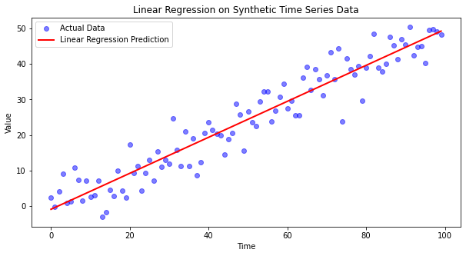

RESULT:
The program to implement linear regression is created and executed successfully.

